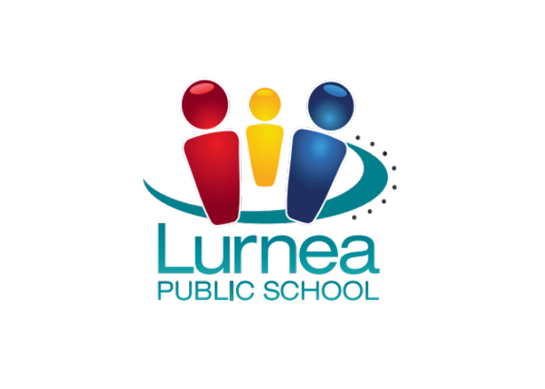

NSW Department of Education and Communities

Lurnea Public School
Safe, Respectful Learners

West and Reilly Streets
Lurnea NSW 2170

P: 9607 6001
F: 9608 4938
E: lurnea-p.school@det.nsw.edu.au
W: www.lurnea-p.schools.nsw.edu.au
FB: www.facebook.com/LurneaPublicSchool

Wednesday 15 October

Dear Parents and Carers

Stage 3 is happy to present you with their Term 4 fundraiser. Below is an outline of this
unique fundraising idea.
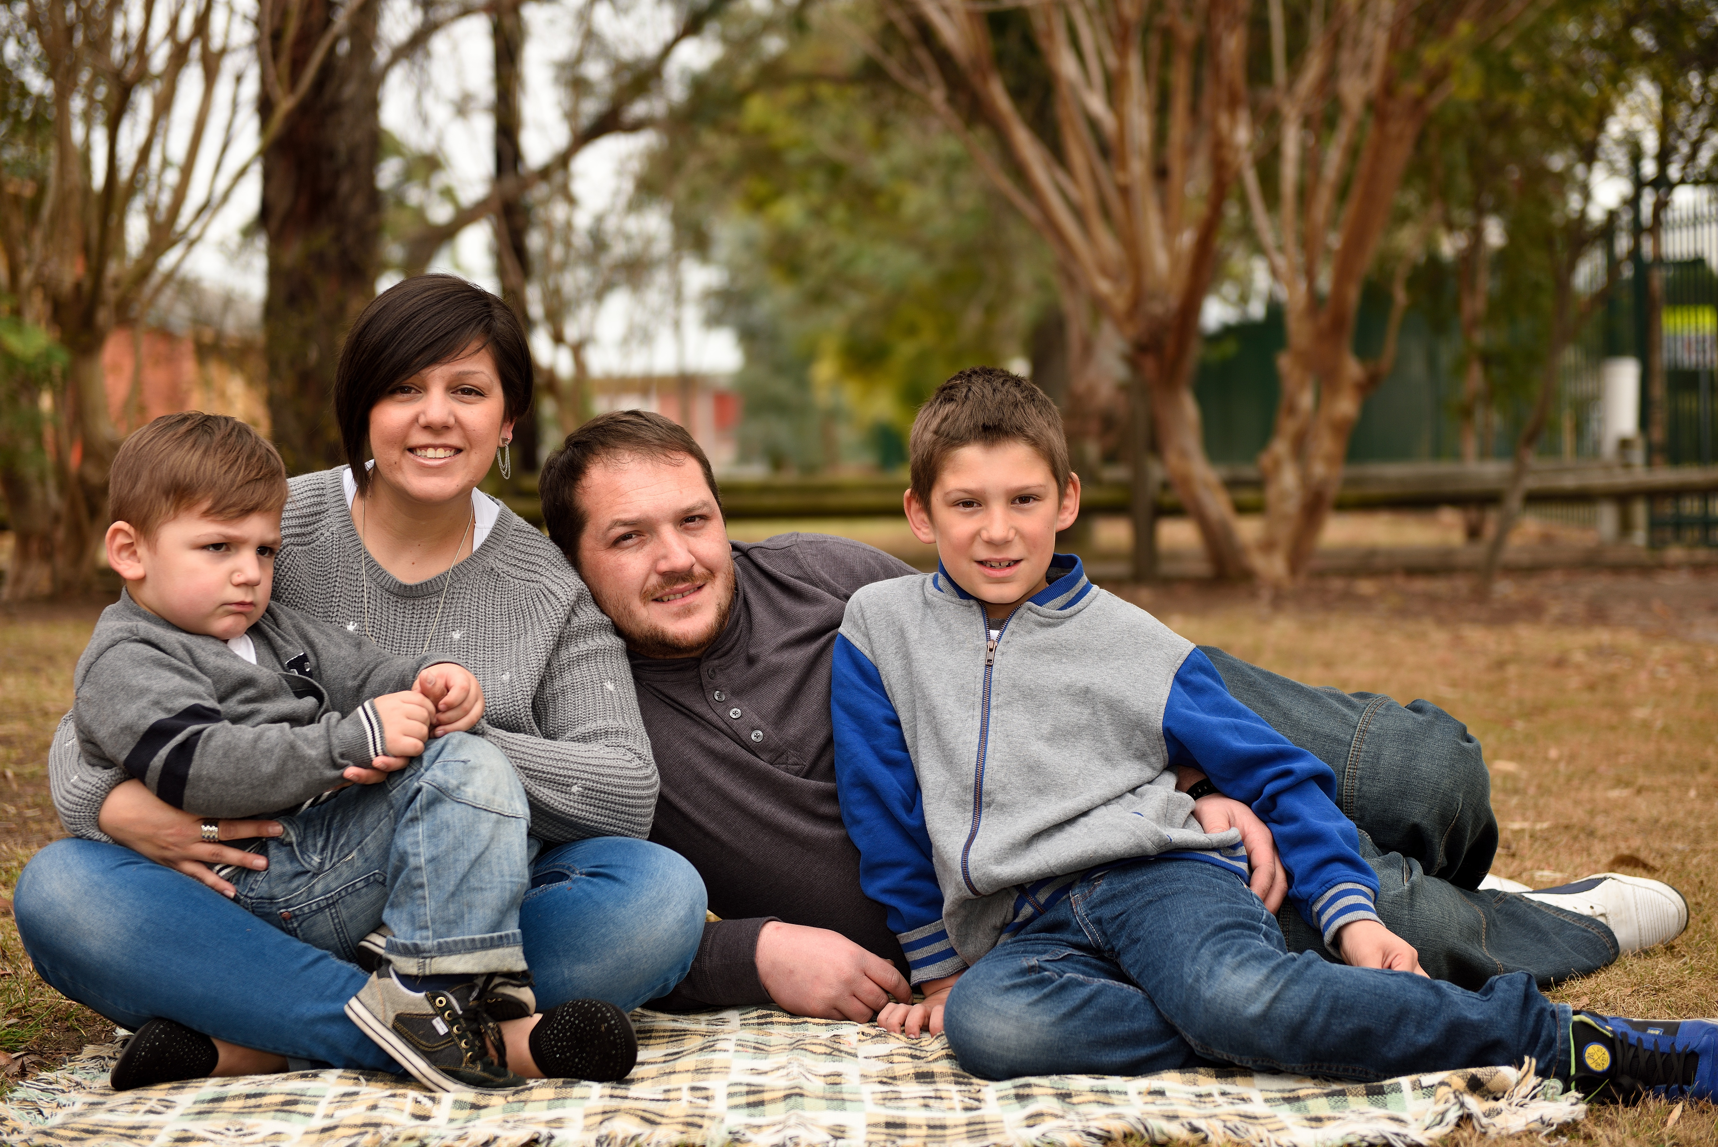
- $20 photography package consisting of 1 x A4 size image and a free 4×6” size printed image.
- A single sitting per family
- Families can choose to colour scheme their outfits.
- The photo can either be as a family portrait or children photo.
- Printed on quality, gloss photography paper.
- Highest quality HD resolution images.
- Great as gifts for family and friends.
- Photos will be distributed before the end of Term 4.

Photography sessions will be held on Saturday 22 November 2014 on the school grounds between 9am and 4pm. All payments to be made to the school office by 14 November to secure your booking place, as no payments can be accepted on the day. Additional $20 packages can be ordered when paying at the school office before the day.

Parents can choose a suitable time by logging into the link below or phoning the school office on 9607 6001.

To book your session time on the Internet you will need to go to www.schoolinterviews.com.au. Bookings will close on 14 November and you will need to phone or contact the school after this date. See page 2 for additional booking details.

Jason Clarke
Stage 3 Teachers John Joy Phillip Plumridge Lauren Dunlop
Assistant Principal Deputy Principals Principal (R)

Photography Sessions - Booking Directions

Located the website www.schoolinterviews.com.au and enter the
Event Code: SSWTC

Then follow these steps to complete your booking:

- Enter your details.

- Select Nada Photography as the class teacher.

- Select a time.


When you click finish, your interview timetable will be emailed to you automatically - check your junk mail folder if you do not receive your email immediately.
You can return to www.schoolinterviews.com.au at any time and change your interviews - until bookings close.

Parents and Carers may send a note to school with the approximate times they require, or phone the school on 9607 6001. Photography sessions are strictly 10 minutes and spaces are limited. If you require more time, please contact the school office directly to make alternative arrangements.

Parents and Carers can change their photography sessions, any time prior to the closing date, by re-visiting the www.schoolinterviews.com.au website, and using the event code. Remember to use the same name and email address, you used when you made your original booking. Parents and Carers wishing to change their photography sessions times after the closing date, should contact the school directly on: 02 9607 6001

We would love to hear what you think about online booking. If you get time, click on the “contact us” button on the www.schoolinterviews.com.au website, and leave some feedback - anonymously if you wish, but please include the school’s name and suburb.

